AI Enhances the Product Development Process by Leveraging Marketing

Tanvi Bhosale

Capital College, Penn State Harrisburg

INFSY 540: Literature Review

Dr. Roderick L. Lee

December 10, 2023

**Abstract**

**Building products in a competitive ecosystem always comes with its challenges to steer the entire organization towards a common goal. The aim is achieved in a methodical manner with the support of the Product Development Process (PDP). Additionally, marketing has grown into being an inclusive part of the PDP process. Artificial intelligence (AI) plays a significant role in enhancing this PDP process. This paper focuses on providing a deeper insight into the pre and post minimal viable product (MVP) marketing activities which are enhanced using AI. A few success cases are shared to highlight the advantages of employing AI to improve PDP processes by utilising marketing. The paper finishes by outlining the potential for future developments in the application of AI to PDP and marketing, with the goal of achieving automation and improved customer experience as a means of creating profitable businesses that can survive in the cutthroat market.**

***Keywords*: *Artificial Intelligence, Product Development Process, Marketing, Minimal Viable Product, Automation, Customer Experience***

AI Enhances the Product Development Process by Leveraging Marketing

**The nexus of Product Development, Marketing and Artificial Intelligence is a very significant area to focus on for many businesses. Strategizing this correlated segment can boost profitability. PDP is a process followed for designing, developing, and marketing a new product in the market. In PDP various steps are carried out before and after developing a launchable minimal viable product. It includes conceptualizing an idea which involves generating diverse ideas to potentially solve a problem being faced by the targeted customers. Conducting market research to understand requirements. After ideation and analysis, the product gets defined to work on developing a minimal viable product that satisfies all the requirements of the customer. On validating and testing the product it is launched in the market and commercialized.**

**Marketing plays a crucial role in the product development process. It is a very integrated part of product development. Two ways the marketing highly displays its impact on the product are pre-MVP and post-MVP. Marketing is an umbrella which includes marketing research where data collection, market analysis, and customer understanding is performed. It also works with marketing strategy where segmentation, targeting, and positioning is performed. And covers marketing actions inclusive of standardization, personalization and relationalization. There three activities work in a correlative loop (**Huang & Rust, 2021)**.**

**Artificial Intelligence plays a vital role in enhancing the product development process using marketing strategies. AI benefits marketing management by automating decision making process and analysing the competitors using Machine Learning, Big Data Analytics, AI platform solutions to develop better customer relationships, enhance marketing measurements, make faster decisions based on data, understand emerging trends, and boost progressive learning (Pathak & Sharma, 2022). The major role that AI plays in marketing and PDP correlation is by analysing competitors, performing market research and predictive analytics as pre-MVP actions. While handling mapping customer journey, data driven decision making and automation as post-MVP activities. Such adoption of AI has proved to bring a noteworthy increase in business, an approximate of quarter billion dollars (Brem & Werle, 2023).**

**In this literature review, we go through various peer-reviewed and conference papers to get a closer look at these AI induced activities performed in PDP marketing, its benefits and explore future enhancements.**

# ****Methodology of Literature Search****

**There are references to several publications and conferences found in the literature search. Peer review was one of the primary factors used to filter materials. Using terms such as "Artificial Intelligence," "Market*," "Product Development," and "Machine learning" together with connecting keywords like AND, OR, etc., one might browse the IEEE journal, and a few more journals. The most recent publications over the preceding five years were selected from a database including hundreds of journal articles. Additionally, the ones that fit the information systems STEM domain's topic of the literature study were chosen for further study. Following Venn Diagram represents the count of papers and the topic those papers have discussed (see Figure 1).**

**Figure 1**

***Domain Distribution based Venn Diagram***

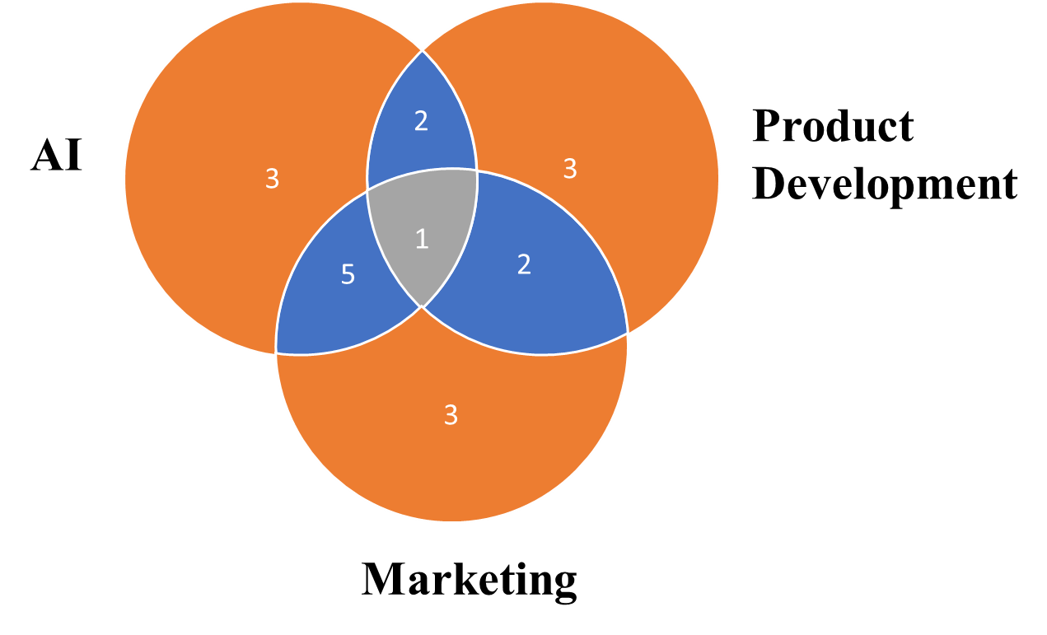

# ****Artificial Intelligence used in PDP****

**Product development process comprises of conceptualization, ideation, market understanding, product definition, product development, testing, launch and marketing. Based on project characteristics, AI may automate operations, offer new design methods, analyse material alternatives, test prototypes, and make recommendations (Rath et al., 2022). With AI assistance, engineering teams would be able to iterate more quickly and make design modifications in real time. Furthermore, AI will assist engineers in identifying and eliminating hazards connected to safety and human aspects. This would not only lower the chance of product recalls, but it would also increase customer satisfaction.**

**AI can help analyse huge amounts of data for understanding the shortcomings to take data-based decisions. It can understand patterns and trends to comprehend better insights on achieving product goals. Better automation tools can also be developed using big data and machine learning. By analysing user information and usage factors artificial intelligence can derive strategic judgement for generating personalized advertisement of the product. AI powered tools can increase the return value by developing predictive model to generate personalized content for the customers to tailor the experience for every individual (**Haleem et al., 2022)**. Machine learning models assist in determining the target audience to determine more accurate product definition. To sum it up Artificial Intelligence in PDP results in cost reduction, improved decision-making, process optimization, minimal production time, better product quality, and enhanced customer experience.**

# ****Artificial Intelligence used in Marketing****

**As automation is being more enabled in the industry with the use of artificial intelligence, scope for creative marketing has increased. Artificial intelligence can assist in developing more effective marketing strategies, enhancing the customer journeys, and transformation in customer acquisition strategies (Ameen et al., 2022). Different artificial intelligence techniques like machine learning and random forests can narrow down the target audience for marketing, AI can also help strategize and plan marketing opportunities, and perform segmentation, positioning and targeting activities (Verma et al., 2021).**

**A marketing analytics tool powered by artificial intelligence can assess how well a product design meets consumer demands and how satisfied customers are consequently. The system's ability to support service innovation and designs is enhanced by topic modelling (Verma et al., 2021). Marketers may better comprehend the product recommender system and coordinate their marketing plans for effective product management by considering the preference weight provided to product features during product search. Deep learning facilitates travel and allows for customization of the point of interest recommendation. Artificial intelligence provides the ability to tailor products to the demands of the consumer. AI methods like neural networks and seep learning plays a crucial role in performing market analysis to extract the understanding of market competitors and trends** (Huang & Rust, 2021)**.**

# ****Mediator-Moderator Framework****

**Figure 2**

***Mediator Moderator Model* 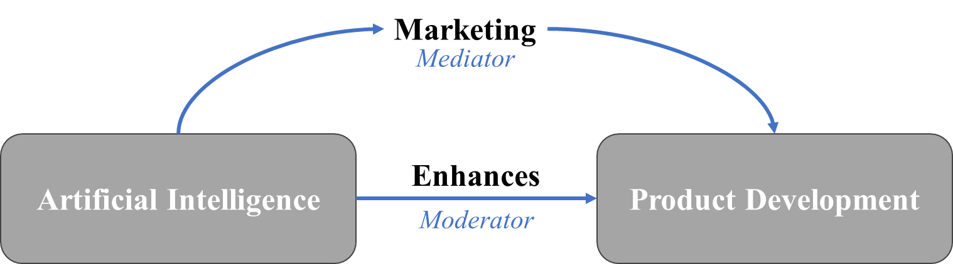**

**In statistical models, both mediation and moderation can take place simultaneously. When the treatment impact of an independent variable on an outcome variable via a mediator variable varies based on levels of a moderator variable, this is referred to as moderated mediation, also known as conditional indirect effects. While a moderating variable (also known as a moderator) influences the direction and intensity of a connection, a mediating variable (also known as a mediator) describes the mechanism by which two variables are associated. We may get a more complete view of the real world by include mediators and moderators in your research instead of only focusing on the straightforward link between two variables (Ameen et al., 2022). When researching intricate correlational or causal links between variables, these factors are crucial to consider.**

**As shown in Figure 2, independent factors can influence a dependent variable through mediators. They describe the link between the two and explain how and why. A mediator affects the dependent variable and is always a result of the independent variable. Think of a mediator as the "go-between" for the dependent and independent variables. In this instance, marketing serves as a liaison between product development and AI. Compared to the independent variable "AI," the mediator "Marketing" has a more direct impact. The indirect variable has an influence on the direct variable through the mediator. According to the mediation flow chart, the mediator is caused by the independent variable "AI," the mediator must alter the dependent variable "Product Development," and the mediator modifies the correlation or link between the independent and dependent variables.**

**Moderators examine interactions. The degree to which the moderator, or a third variable, affects the connection between the independent and dependent variables is known as the moderation analysis. Because they have the power to influence the direction or degree of the link between the independent and dependent variables, moderator variables are also frequently referred to as interactions or products. They either strengthen or weaken the link, or they shift its effect from strong to moderate to non-existent. Moderators may be qualitative or quantitative in nature. For example, in this instance, "Enhances" is a qualitative moderator. Since the moderator affects the connection's degree, direction, and strength, it may also be adjusted to measure how much the relationship between the variables has changed.**

# Product Development Process Leverages Marketing

The Product Development Process (PDP) covers processes such as product creation, design, and marketing. Throughout the process, the product should be focused on its completeness, quality, and vital characteristics (Micus et al., 2023). To do this, knowledge about target consumers and customer use statistics can prove very beneficial. Using this data to do analytics may assist in carrying out the many PDP phases such as correctly identifying the product, diagnosing whether the product answers the core problem, eliminating the unnecessary, developing a consumer-focused product, and making data-driven decisions. Essentially, marketing may be an invaluable resource for understanding consumer needs before creating a minimum viable product utilizing the PDP process, as well as providing the product with a greater and more diverse customer reach. With the advancement of AI models, leveraging social media networks to reach a broader audience has become a critical marketing technique for attracting customers (Milan et al., 2023).

**What is a Minimum Viable Product**

Minimum Viable Product is referred to as MVP. An MVP is a version of a product with enough functionality to be launched for general usage but very few features. For early adopters, a minimal viable product is typically appropriate. A complete feature set that will satisfy the demands of a larger user base may be built when input from these early adopters has been obtained. When defining an MVP, three key characteristics need to be considered: the MVP needs to be valuable enough for people to try it out, beneficial enough to keep these early adopters around, and offer chances for feedback so that the product may be improved. Crucially, the MVP needs to be practically viable and beneficial to the target market. Thus, MVP stands to be a very important phase of the product development process.

**Pre-MVP marketing**

Conducting marketing prior to the release of the MVP will aid the product development process in the industry. This may be accomplished by employing Big Data to do Machine Learning, Data Analytics, and Predictive Analytics on customer usage data and customer requirements. Using AI models can aid in the development of a deeper neural network to correlate the required product upgrades while also optimizing the outcome of the feature addition. An intensive market study prior to producing the MVP can help create the product in the most customer-focused way possible. The competition would assist in the understanding of the customer base, trends, pricing tactics, strategizing personalization, and would lead to the establishment of a competitive edge. Customer journey mapping can empower a product to succeed in the market by plotting the customer's pain points, generating innovative concepts, considering numerous personas, discussing different phases, and noting chances to make the product stand out. All of these can be enabled by using AI and leveraging marketing strategies.

**Post-MVP marketing**

The introduction of a minimal viable product onto the market aids in determining client satisfaction with the product. Product performance is revealed through reviews, postings, newsletters, blogs, and social platforms. This data may then be utilised to develop a more personalised and automated version of the product that focuses not just on essentials but also on luxury (Davenport et al., 2020). Decisions would be more data-driven rather than solely predicted. Future marketing tactics can be created depending on the customer's post-MVP release response. Based on the acquired data, more effort may be done to improve the consumer usage experience and optimization.

**AI enhances the MVP Marketing**

Marketing is crucial both before and after the release of the minimum viable product. This can be improved by incorporating AI approaches. Marketing can work in a cyclical fashion to design, deploy, and enhance a product. Market research is an essential element in the product development process. AI can facilitate this study by utilising various algorithms like as clustering to process data collecting, natural language processing to comprehend client emotions, and text mining to evaluate the market. Artificial intelligence may help marketers’ strategy marketing by undertaking segmentation, audience targeting, and AI-based optimisation in positioning. This is followed by marketing initiatives such as standardisation, personalisation, and correlation of products utilising AI and machine learning algorithms (Huang & Rust, 2021).

**Competitive Market research**

Market research gives you an advantage over your competition. It is possible to do this by employing artificial intelligence to track, gather, and process customer and market data (Huang & Rust, 2021). Using AI algorithms, market analysis may be used to detect competitors, market trends, and competitive advantages. Analytics on customer big data may be used to better understand current and prospective consumer demands and desires. Data-driven marketing allows for feature selection based on marketing strategy. As a result, it gives a detailed understanding of client behaviour and evaluates patterns in order to make future product selections (De & Baroi, 2022).

Marketing activity management focuses on pricing, product, location, and promotions. The goal of these actions is to attract new consumers, meet customer expectations, increase profitability, and build brand value. AI can enhance these marketing activities by using an algorithm to predict the best market price, increasing product awareness among target customers, defining demographic focus and alterations using AI algorithms, and advertising the product and its benefits in the market using machine learning and artificial intelligence (Pathak & Sharma, 2022).

**Customer Journey mapping**

AI algorithms and machine learning models can analyse vast volumes of data, such as consumer behaviour patterns, preferences, and histories. Businesses may now adjust their customer interactions and interfaces to fit the exact requirements and preferences of individual consumers, thanks to these insights. This can lead to increased consumer satisfaction and, eventually, loyalty. AI also brings predictive analytics to the forefront. By analysing historical patterns and data trends, AI technologies can forecast future client behaviour. Businesses may anticipate consumer wants, optimise their offers, and create a more efficient, personalised customer journey because of this (Tanveer et al., 2021). Businesses can now map consumer journeys in real time using AI. This allows them to quickly detect and resolve any faults or hurdles that consumers may encounter, resulting in a more pleasant customer experience.

A customer journey map enables to pinpoint the micro-moments that comprise brand's overall experience. Micro moments that, when examined and improved, imply the difference between decent service and outstanding service; wonderful products and unforgettable ones; pleased customers and euphoric, review-writing, recommending, devoted consumers. To put it another way, customer journey mapping is the process of understanding and improving the experience at every level to provide the personalised experience that customers want today, which includes directing content marketing approach. Increases the quality of goods, services, and marketing material. Allows for cross-channel and omnichannel marketing. Increases retention across the funnel and distinguishes from competition.

A marketing funnel is one component of a customer journey map. This is a graphic depiction of how leads become customers, and customers become loyal customers for businesses. The process is deconstructed into its several stages and the offerings at each one, which are as follows: Awareness, Interest/consideration, Evaluation, Desire, Action/conversion, and Retention.

**Benefits of AI in PDP Marketing**

**AI based predictive algorithms referred to as intelligent marketing automation have been driving marketing operations and efficiencies, including branding and sales forecast (Ameen et al., 2022). Artificial Intelligence (AI) revolutionizes marketing management with a multitude of benefits, including increased Campaign Return on Investment (ROI) through real-time data analysis and resource optimization. AI facilitates better customer relationships and real-time personalization by enabling personalized communication and identifying at-risk customers** (Pathak & Sharma, 2022)**. Marketing measurement is enhanced with AI-powered dashboards, providing comprehensive insights for informed decision-making. Faster decision-making is achieved as AI performs quick data analysis, freeing up time for strategic focus.**

**Success with AI requires a focus on talent management, data strategy, and ongoing analysis of customer feedback. AI aids in customer segmentation, understanding motivations, and cultivating long-term relationships. It drives emerging trends such as personalization, accurate forecasting, and increased automation (Jarek &** Mazurek**, 2019). AI assists in profound hunting by monitoring client search trends and identifying critical focus areas (Kaur et al., 2022). Genius advertisements leverage AI's analysis of customer data for intelligent and successful marketing strategies. Filtered content, driven by AI analytics, ensures personalized and relevant content delivery. AI bots, including chatbots, contribute to customer retention, saving time and resources. Progressive learning allows AI to integrate hidden insights into ongoing campaigns, becoming progressively more intelligent over time (Mustak et al., 2021; Qin & Mross, 2022; Shulman et al., 2023; Wu & Monfort, 2023).**

**Conclusion**

**In conclusion, the integration of Artificial Intelligence (AI) into the Product Development Process (PDP) and marketing presents a transformative paradigm for businesses aiming to navigate the challenges of a competitive landscape. The symbiotic relationship between product development, marketing, and AI offers a methodical approach to achieving common organizational goals. This paper delves into the pre- and post-Minimal Viable Product (MVP) marketing activities, emphasizing the pivotal role of AI in enhancing these processes. The Minimum Viable Product (MVP) phase is a critical juncture in the PDP, and AI-driven marketing activities both before and after its release significantly impact a product's success. AI supports pre-MVP marketing through Big Data analysis, segmentation, and customer journey mapping, providing invaluable insights for customer-focused product development. Post-MVP, AI leverages customer feedback and data for more personalized and automated products, guiding data-driven decisions for future marketing tactics.**

**The Product Development Process encompasses various stages, from ideation to launch, and AI emerges as a catalyst for innovation at every step. AI aids engineering teams in quicker iterations and real-time design modifications, contributing to enhanced product quality and customer satisfaction. By analysing vast amounts of data, AI facilitates better decision-making, process optimization, and the derivation of strategic insights for personalized advertisements. This not only reduces costs but also significantly improves customer experiences. The use of AI in competitive market research and customer journey mapping brings unparalleled advantages, enabling businesses to stay ahead of trends, enhance product positioning, and personalize customer experiences.**

**The benefits of AI in PDP and marketing are extensive, ranging from increased ROI and better customer relationships to profound hunting and genius advertisements. AI's progressive learning capabilities ensure continuous improvement, making it a cornerstone for businesses aiming to thrive in a cutthroat market. As we look to the future, the paper underscores the potential for continued advancements in AI applications, with a focus on automation and enhanced customer experiences to create sustainable and profitable businesses. The successful integration of AI into PDP and marketing not only ensures survival in a competitive landscape but also positions businesses at the forefront of innovation and efficiency.**

**Future advancements**

**The future exploration of AI in the integration of the Product Development Process (PDP) and marketing offers exciting prospects for businesses seeking to elevate their capabilities. Advancements in predictive analytics stand as a key avenue, with a focus on refining algorithms to anticipate market trends and consumer behaviour more accurately. Augmented Reality (AR) integration in the PDP is another promising area, where AI-driven simulations could revolutionize product prototyping and testing. Ethical considerations in AI-driven marketing strategies require attention, urging researchers to delve into ensuring fairness, transparency, and responsible use.**

**Human-AI collaboration is an intriguing frontier, exploring ways in which AI can complement human creativity in product development processes. Dynamic personalization in marketing, AI-generated content creation, and blockchain integration for data security are areas poised for further exploration. The cross-functional application of AI with emerging technologies, such as IoT and 5G, could yield comprehensive solutions. Enhanced customer feedback analysis, focusing on sentiment analysis and natural language processing, promises deeper insights. Lastly, navigating AI regulations and ensuring compliance with data protection laws will be essential for businesses embracing the transformative potential of AI in both product development and marketing strategies. These avenues collectively contribute to shaping an intelligent, ethical, and interconnected future for businesses leveraging AI.**

**References**

Ameen, N., Sharma, G. D., Tarba, S., Rao, A., & Chopra, R. (2022). Toward advancing theory on creativity in marketing and artificial intelligence. *Psychology & Marketing*, *39*(9), 1802–1825. <https://doi.org/10.1002/mar.21699>

Brem, A., Giones, F., & Werle, M. (2023). The ai digital revolution in innovation: A conceptual framework of artificial intelligence technologies for the management of innovation. *IEEE Transactions on Engineering Management, 70(2),* 770–776. <https://doi.org/10.1109/TEM.2021.3109983>

Davenport, T., Guha, A., Grewal, D., & Bressgott, T. (2020). How artificial intelligence will change the future of marketing. *Journal of the Academy of Marketing Science*, *48*(1), 24–42. <https://doi.org/10.1007/s11747-019-00696-0>

De, S., & Baroi, I. (2022). Evolution of analytics in product management for data-driven feature prioritization. *2022 Seventh International Conference on Parallel, Distributed and Grid Computing (PDGC)*, 588–593. <https://doi.org/10.1109/PDGC56933.2022.10053237>

Haleem, A., Javaid, M., Asim Qadri, M., Pratap Singh, R., & Suman, R. (2022). Artificial intelligence (Ai) applications for marketing: A literature-based study. *International Journal of Intelligent Networks, 3,* 119–132*.* <https://doi.org/10.1016/j.ijin.2022.08.005>

Huang, M.-H., & Rust, R. T. (2021). A strategic framework for artificial intelligence in marketing. *Journal of the Academy of Marketing Science, 49(1),* 30–50*.* <https://doi.org/10.1007/s11747-020-00749-9>

Jarek, K., & Mazurek, G. (2019). Marketing and artificial intelligence. *Central European Business Review*, *8*(2), 46–55. <https://doi.org/10.18267/j.cebr.213>

Kaur, R., Singh, R., Gehlot, A., Priyadarshi, N., & Twala, B. (2022). Marketing strategies 4. 0: Recent trends and technologies in marketing. *Sustainability*, *14*(24), 16356. <https://doi.org/10.3390/su142416356>

Micus, C., Schramm, S., Boehm, M., & Krcmar, H. (2023). Methods to analyze customer usage data in a product decision process:A systematic literature review. *Operations Research Perspectives*, *10*, 100277. <https://doi.org/10.1016/j.orp.2023.100277>

Milan, A., Sahu, R., & Sandhu, J. K. (2023). Impact of ai on social marketing and its usage in social media: A review analysis. *2023 International Conference on Circuit Power and Computing Technologies (ICCPCT)*, 1749–1754. <https://doi.org/10.1109/ICCPCT58313.2023.10245676>

Mustak, M., Salminen, J., Plé, L., & Wirtz, J. (2021). Artificial intelligence in marketing: Topic modeling, scientometric analysis, and research agenda. *Journal of Business Research, 124,* 389–404. <https://doi.org/10.1016/j.jbusres.2020.10.044>

Pathak, A., & Sharma, S. D. (2022). Applications of artificial intelligence (Ai) in marketing management. *2022 5th International Conference on Contemporary Computing and Informatics (IC3I),* 1738–1745*.* <https://doi.org/10.1109/IC3I56241.2022.10072425>

Qin, L., & Mross, E. (2022). *Exploratory case studies of organizational ai applications in marketing*. <https://scholarsphere.psu.edu/resources/11fbeafe-bf63-465a-805a-79e8d13e2206>

Rath, R. C., Baral, S. K., Singh, T., & Goel, R. (2022). Role of artificial intelligence and machine learning in product design and manufacturing. *2022 International Mobile and Embedded Technology Conference (MECON)*, 571–575. <https://doi.org/10.1109/MECON53876.2022.9752455>

Shulman, J. D., Toubia, O., & Saddler, R. (2023). Editorial: Marketing’s role in the evolving discipline of product management. *Marketing Science*, *42*(1), 1–5. <https://doi.org/10.1287/mksc.2022.1428>

Tanveer, M., Khan, N., & Ahmad, A.-R. (2021). Ai support marketing: Understanding the customer journey towards the business development. *2021 1st International Conference on Artificial Intelligence and Data Analytics (CAIDA),* 144–150*.* <https://doi.org/10.1109/CAIDA51941.2021.9425079>

Verma, S., Sharma, R., Deb, S., & Maitra, D. (2021). Artificial intelligence in marketing: Systematic review and future research direction. *International Journal of Information Management Data Insights, 1(1), 100002.* <https://doi.org/10.1016/j.jjimei.2020.100002>

Wu, C., & Monfort, A. (2023). Role of artificial intelligence in marketing strategies and performance. *Psychology & Marketing*, *40*(3), 484–496. <https://doi.org/10.1002/mar.21737>